Please tick appropriate project:

ENG5059P (MSc) | √

Student Name | Youqi Cheng
Student GUID Number | 2698734C
Degree programme | Computer System Engineering
Working Title of Project | Longitudinal microbiome analysis of healthy chicken ceca
Name of Supervisor(s) | Umer ljaz
Academic year | 2021-2022

Introduction
Chicken are one of the most important food resources for human consumption. Chicken is rich in nutrients, which supplies good concentrations of all the essential B vitamins with few calories. There are more chickens raised and slaughtered than all other types of livestock combined. It’s estimated that more than 50 billion chickens are raised for meat in the world each year.

But Chicken meat may carry pathogenic bacteria, including Campylobacter, which is a major cause of bacterial foodborne gastroenteritis, and it can also cause Guillain-Barre syndrome, as well as growth retardation in children in low-resource countries. Despite Campylobacter may cause some impact and economic burden, it’s unclear how and when it appears in chickens. The lack of having replicated daily microbiome data, associated metadata, and lack of natural infection studies have all delayed our understanding of the chicken gut microbiome and Campylobacter.

So it is important to study the relationship between the changes of Campylobacter in the chicken gut and the environment. This study performed a microbiome analysis of 16S rRNA samples collected from days 3 to 35 of the chicken cecum, in a natural environment known to be extra prevalent in Campylobacter. Our focus is on understanding how the cecum microbiota develops, and the potential ecological phenomena that make up the microbial community. ”

Aims/Objectives of project
By analyzing the sample data in the chicken gut between day 3 to day 35, explore how the cecum microbiota develops, how it was affected by the environment, and understand ecological phenomena that structure the microbial communities.

Resources required
- Dataset
- R and R studio
- Paper refrences
- Suitable algorithm

GANTT chart

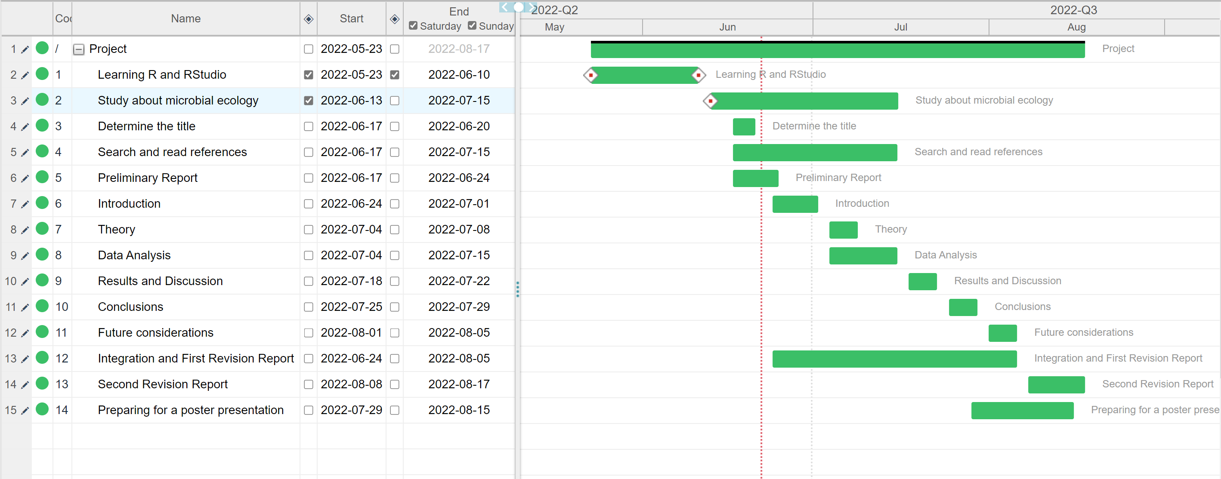

Risk assessment
1.
Risk: Unavailability of data
Likelihood without control measures: Improbable
Severity: Slight
Control measures to mitigate risk: The data for the project is provided by the supervisor, and is available on a shared repository as well as a backed up
Likelihood with control measures: Improbable

2.
Risk: Data corruption
Likelihood without control measures: Unlikely
Severity: Moderate
Control measures to mitigate risk: The project data is provided on a Dropbox repository (which maintains history for 30 days), as well as saved as a local copy on personnel computer, and in the event of data corruption, the extra copies will be used
Likelihood with control measures: Unlikely

Risk: Mental fatigue
Likelihood without control measures: Likely
Severity: Moderate
Control measures to mitigate risk: The project involves support of additional volunteers (who are PhD students/PDRAs associated with the supervisor's lab), as well as benefits from working in a team environment, with specific and measurable weekly milestones, ensuring the work is balanced in the duration of the project. The training and support is provided by the supervisory team, and access to statistical tools (existing programming codes from numerous projects) ensures reduced anxiety and concerns.
Likelihood with control measures: Likely

